**1. INTRODUCTION**

While the IMDb (http://www.imdb.com/) movie database serves as a useful repository of movie information, it’s use as a source for aggregate movie reviews is limited. While sites like Rotten Tomatoes (http://www.rottentomatoes.com/) serve as a community portal for reviewers to come together as a community and collectively rate movies, they fall short in their ability to allow the user to quickly track the contributing artists that are part of the movie production (i.e. directors, actors, producers, etc.).

In order to create a more comprehensive site for EverythingMovies, the database schema must be

comprehensive enough to allow for multiple simultaneous queries (generated from HTML user forms through a JSP tag library architecture) through a “round-

robin” JDBC connection pool, while still allowing for real time updates and contributions by the user community. Also, the schema must be designed to allow for table abstraction across a hardware topology with an index that exists upon its own network server (again for ease of scalability across a server topology as the connection pool grows to accommodate the anticipated user community). Our intent is to make the database public domain with a Creative Commons usage license. The license will allow for reuse as long as there is a click-through “EverythingMovies” brand icon present on the web site that makes use of our database engine. EverythingMovies will utilize a click-thru revenue sharing scheme as the primary revenue model.

While the Oracle DB architecture has historically proven to be scalable through a variety of

software and hardware optimization strategies, we also recognize that utilization of a schema that infers Oracle exclusivity may not be in the best interest(s) of the adapting user community that we want to attract with our data offering. Therefore, every attempt will be made to homogenize the SQL in order to allow for data loading into other database engines, specifically PostgreSQL and MySQL. The initial POC effort may use one of these “open source” database engines as necessary due to budgetary constraints.

**1.1 Basic Requirements**

The goal of our client is to create a new type of movie web site that is more comprehensive than the

popular ones that currently are available on the Internet. The primary goal of our effort is to create a “proof of concept” system that could serve as a prototype for illustrating the concepts to potential Venture Capital funding sources. Additionally, the database schema will be used to iron out potential scalability issues that might arise if views are required that weren’t considered during database design (this could arise, for instance, if the initial VC round comes with functional considerations that were outside the initial scope of the project).

**1.2 Identification of the Different Types of Users and Queries**

In this section, we identify three different types of users to whom our database is directed other than the database administrators. We also statewhat information (given the relations identified above)should be accessible to each user). In addition, we write five SQL queries to address the needs of these users.

The three different types of users that will use our database are:

1. **Clients of the database** - people who want to use the database to find information about movies. This group can be potentially devided in (a) casual clients who would search the database for any (common) information about the movies, their actors, directors, awards won, et cetera and (b) specialized clients with more complicated search requests. In either case, the implementation of the query interface is the same for most of the users.

2. **Contributors to the database** - people who are going to add new information to the d

atabase. These people differ from the system administrators in that they only add information based on prespecified constraints.

3. **System administrators** -people who will manage and upgrade/alter/program the database. This group,however, is –in every sense –the same as the database administrators.

**1.2.1 Basic queries**

Below, we include examples of the queries that the two basic types of users of the database (defined as clients and contributors above) might find useful.

1. Clients of the database -queries

Query CL1) - Given a specific time period, a user might be interested in finding the top

(three, five, ten) box office movies aired in a given region (say, North America).Query CL2)

Given actor’s/actress’ name, a user might want to find the find the movies that the actor/actress acts in.

Query CL3)-Given the title of the movie (e. g., “Titanic”), a user might want to find out who

are the cast members for the movie specified or, what are the awards won by agiven movie.

Query CL4) - At other times, a user might want to search all the awards won by a given movie.

1. Contributors of the database -queries

Query CO1) - A contributor might want insert, update, or delete a movie or a show to/from

the database (this query is illustrated in Chapter 6, page 46 of this report).

Query CO2)A contributor might want insert or update the database with any other releva

**2. SCHEMA DIAGRAM**

movie_details

|  |  |  |  |
| --- | --- | --- | --- |
| Movie_title | Director_name | Actor_name1 | genre |

Cast_details

|  |  |  |  |
| --- | --- | --- | --- |
| Actor_name1 | Actor_name2 | Actor_name3 | Movie_title |

investment_profit

|  |  |  |  |
| --- | --- | --- | --- |
| budget | gross | movie_title | year |

review

|  |  |  |  |
| --- | --- | --- | --- |
| Director_name | Num_user | Num_critic | Imdb |

other_details

|  |  |  |  |
| --- | --- | --- | --- |
| country | **l**anguage | Plot | Imdb |

1. **TABLES USED:-**

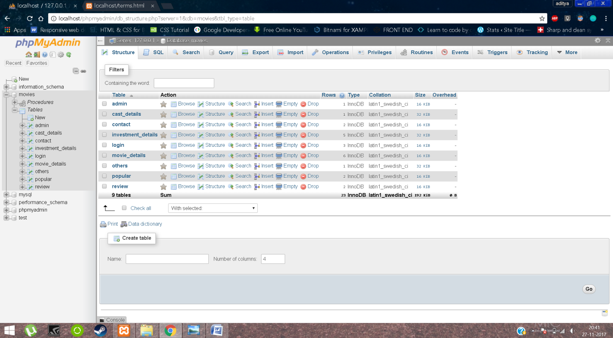

The Tables used in personalized database management system are as follows:-

1. movie_details

* movie_title
* director_name
* actor_name1
* genre

2. cast_details

* actor_name1
* actor_name2
* actor_name3
* movie_title

3. investment_profit

* budget
* gross
* movie_title
* year

4. review

* num_critic
* num_user
* imdb
* director_name

5. other_details

* imdb
* country
* language
* plot

**4. E-R DIAGRAM**

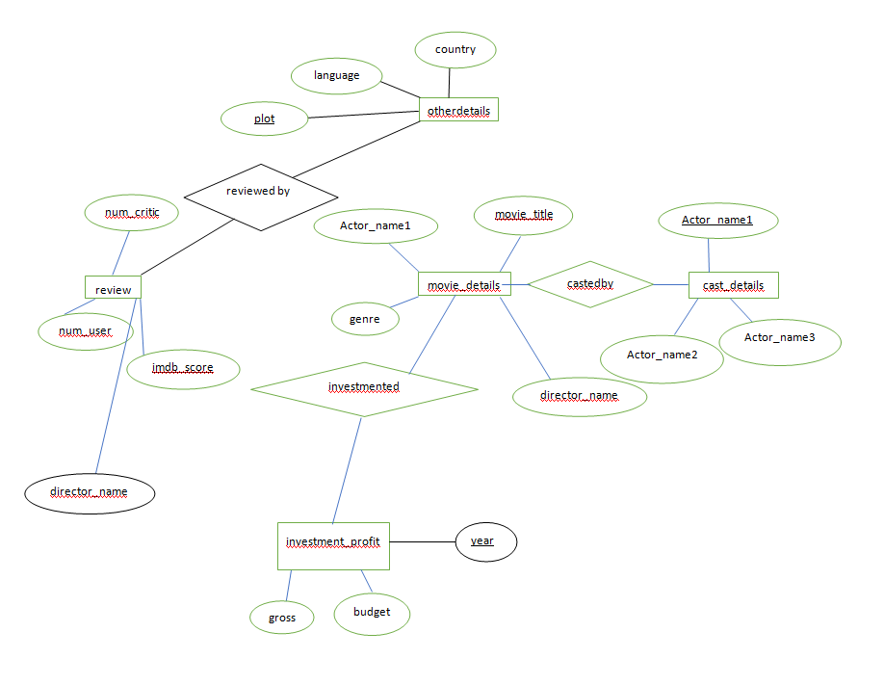

**5. SOFTWARE AND HARDWARE REQUIREMENT**  
PMDS is implemented using the following tools/technologies.  
  
**5.1 PHP**

PHP stands for Hypertext Preprocessor and is a server side scripting language for web development. It can also be used for general-purpose programming. The reference implementation of PHP is produced by the PHP group. The web server consists of a PHP processor module, which interprets the code and generates the resulting web page. The commands in PHP can be directly embedded in the HTML without the need to call an external file to process the data. PHP can be deployed on most of the web servers and can also be used as stand-alone shell on almost every operating system and platform.

**5.2 HTML**

Hypertext Markup Language (HTML) is the standard [markup language](https://en.wikipedia.org/wiki/Markup_language) for creating [web pages](https://en.wikipedia.org/wiki/Web_page) and [web applications](https://en.wikipedia.org/wiki/Web_application). With [Cascading Style Sheets](https://en.wikipedia.org/wiki/Cascading_Style_Sheets) (CSS) and [JavaScript](https://en.wikipedia.org/wiki/JavaScript) it forms a triad of cornerstone technologies for the [World Wide Web](https://en.wikipedia.org/wiki/World_Wide_Web). [Web browsers](https://en.wikipedia.org/wiki/Web_browser) receive HTML documents from a [web server](https://en.wikipedia.org/wiki/Web_server) or from local storage and render them into multimedia web pages. HTML describes the structure of a web page [semantically](https://en.wikipedia.org/wiki/Semantic_Web) and originally included cues for the appearance of the document.

[HTML elements](https://en.wikipedia.org/wiki/HTML_element) are the building blocks of HTML pages. With HTML constructs, [images](https://en.wikipedia.org/wiki/HTML_element#Images_and_objects) and other objects, such as [interactive forms,](https://en.wikipedia.org/wiki/Fieldset) may be embedded into the rendered page. It provides a means to create [structured documents](https://en.wikipedia.org/wiki/Structured_document) by denoting structural [semantics](https://en.wikipedia.org/wiki/Semantics) for text such as headings, paragraphs, lists, [links](https://en.wikipedia.org/wiki/Hyperlink), quotes and other items. HTML elements are delineated by *tags*, written using [angle brackets](https://en.wikipedia.org/wiki/Bracket#Angle_brackets). Tags such as <img /> and <input /> introduce content into the page directly. Others such as <p>...</p> surround and provide information about document text and may include other tags as sub-elements. Browsers do not display the HTML tags, but use them to interpret the content of the page.

HTML can embed programs written in a [scripting language](https://en.wikipedia.org/wiki/Scripting_language) such as [JavaScript](https://en.wikipedia.org/wiki/JavaScript) which affect the behavior and content of web pages. Inclusion of CSS defines the look and layout of content. The [World Wide Web Consortium](https://en.wikipedia.org/wiki/World_Wide_Web_Consortium) (W3C), maintainer of both the HTML and the CSS standards, has encouraged the use of CSS over explicit presentational HTML since 1997.

**5.3 CSS**

Stands for "Cascading Style Sheet." Cascading style sheets are used to format the layout of [Web pages](https://techterms.com/definition/webpage). They can be used to define text styles, table sizes, and other aspects of Web pages that previously could only be defined in a page's [HTML](https://techterms.com/definition/html).

CSS helps Web developers create a uniform look across several pages of a Web site. Instead of defining the style of each table and each block of text within a page's HTML, commonly used styles need to be defined only once in a CSS document. Once the style is defined in cascading style sheet, it can be used by any page that references the CSS file. Plus, CSS makes it easy to change styles across several pages at once. For example, a Web developer may want to increase the default text size from 10pt to 12pt for fifty pages of a Web site. If the pages all reference the same style sheet, the text size only needs to be changed on the style sheet and all the pages will show the larger text.

While CSS is great for creating text styles, it is helpful for formatting other aspects of Web page layout as well. For example, CSS can be used to define the cell padding of table cells, the style, thickness, and color of a table's border, and the padding around images or other objects. CSS gives Web developers more exact control over how Web pages will look than HTML does. This is why most Web pages today incorporate cascading style sheets.

**5.4 BOOTSTRAP**

Bootstrap is a [free and open source](http://searchenterpriselinux.techtarget.com/definition/Free-and-open-source-software-FOSS) [front end](http://whatis.techtarget.com/definition/front-end) development framework for the creation of websites and [web apps](http://searchsoftwarequality.techtarget.com/definition/Web-application-Web-app). The Bootstrap framework is built on [HTML](http://searchmicroservices.techtarget.com/definition/HTML-Hypertext-Markup-Language), [CSS](http://searchmicroservices.techtarget.com/definition/cascading-style-sheet-CSS), and JavaScript ([JS](http://searchmicroservices.techtarget.com/definition/JavaScript)) to facilitate the development of [responsive](http://whatis.techtarget.com/definition/responsive-design), [mobile-first](http://searchmobilecomputing.techtarget.com/definition/mobile-first) sites and apps.

Responsive design makes it possible for a web page or app to detect the visitor’s screen size and orientation and automatically adapt the display accordingly; the mobile first approach assumes that [smartphones](http://searchmobilecomputing.techtarget.com/definition/smartphone), [tablets](http://searchmobilecomputing.techtarget.com/definition/tablet-PC) and task-specific [mobile apps](http://whatis.techtarget.com/definition/mobile-app) are employees' primary tools for getting work done and addresses the requirements of those technologies in design.

Bootstrap includes user interface components, layouts and JS tools along with the framework for implementation. The software is available precompiled or as [source code](http://searchmicroservices.techtarget.com/definition/source-code).

Mark Otto and Jacob Thornton developed Bootstrap at Twitter as a means of improving the consistency of tools used on the site and reducing maintenance. The software was formerly known as Twitter Blueprint and is sometimes referred to as Twitter Bootstrap.

In computers, the word bootstrap means to [boot](http://searchwinit.techtarget.com/definition/boot): to load a program into a computer using a much smaller initial program to load in the desired program (which is usually an operating system).

In the physical world, a bootstrap is a small strap or loop at the back of a leather boot that enables you to pull the entire boot on and in general usage, bootstrapping is the leveraging of a small initial effort into something larger and more significant. There is also a common expression, "pulling yourself up by your own bootstraps," meaning to leverage yourself to success from a small beginning.

**5.5 JAVASCRIPT**

JavaScript is a [programming language](https://techterms.com/definition/programming_language) commonly used in [web development](https://techterms.com/definition/web_development). It was originally developed by Netscape as a means to add dynamic and interactive elements to websites. While JavaScript is influenced by [Java](https://techterms.com/definition/java), the [syntax](https://techterms.com/definition/syntax) is more similar to [C](https://techterms.com/definition/cplusplus) and is based on ECMAScript, a scripting language developed by Sun Microsystems.

JavaScript is a client-side scripting language, which means the [source code](https://techterms.com/definition/sourcecode) is processed by the client's [web browser](https://techterms.com/definition/web_browser) rather than on the [web server](https://techterms.com/definition/web_server). This means JavaScript [functions](https://techterms.com/definition/function) can run after a webpage has loaded without communicating with the server. For example, a JavaScript function may check a web form before it is submitted to make sure all the required [fields](https://techterms.com/definition/field) have been filled out. The JavaScript code can produce an error message before any information is actually transmitted to the server.

Like server-side scripting languages, such as [PHP](https://techterms.com/definition/php) and [ASP](https://techterms.com/definition/asp), JavaScript code can be inserted anywhere within the [HTML](https://techterms.com/definition/html) of a [webpage](https://techterms.com/definition/webpage). However, only the [output](https://techterms.com/definition/output) of server-side code is displayed in the HTML, while JavaScript code remains fully visible in the source of the webpage. It can also be referenced in a separate [.JS](https://fileinfo.com/extension/js) file, which may also be viewed in a browser.

Below is an example of a basic JavaScript function that adds two numbers. The function is called with the parameters 7 and 11. If the code below were included in the HTML of a webpage, it would display the text "18" in an [alert box](https://techterms.com/definition/alertbox).

JavaScript functions can be called within <script> tags or when specific events take place. Examples include onClick, onMouseDown, onMouseUp, onKeyDown, onKeyUp, onFocus, onBlur, onSubmit, and many others. While standard JavaScript is still used for performing basic client-side functions, many web developers now prefer to use JavaScript libraries like [jQuery](https://techterms.com/definition/jquery) to add more advanced dynamic elements to websites.

**5.6 MySQL**

MySQL is an open source database management system. It is developed, supported and distributed by Oracle Corporation. Database is structured collection of data. It can be anything from a simple to do list to vast amount information on some specific network. To add, delete, modify this data we need a database management system and MySQL is one such server. A relational database stores data in different tables. The logical model of the database with objects such as tables, views, rows and columns offer very flexible programming environment. These features make it easy to organize data and give the flexibility of reading or writing to the database by multiple people at the same time. Almost all the applications on web need web-hosting databases. MySQL is a web hosting database which can be used to store website information. It is difficult to maintain and manage databases with just SQL queries and is always easier using graphical user interface (GUI). PMDS was developed using a GUI called PHP my admin for managing the MySQL database. PHP my admin allows us to add, delete and modify database tables and entries. It also helps in creating backup for the database, run some specific SQL queries, search records and import records.

**6. Background and Related Work**

IMDB (Internet Movie Database) is one of the largest movie databases available in the web. It has detailed information about all the movies including movie show times and trailers. But it doesn’t provide the information about “online streaming”. Rotten Tomatoes is another website which primarily gives the combined critic score of any movie. It provides the basic movie data, streaming links but not show times of movies playing in theaters. Movie lens suggests the movies based on user’s ratings for other movies and basic data but no information on “show times” and “ online streaming”. Today, online streaming/renting a movie is widely popular and most of the movies are coming up with an option to rent the movie online at the same time when they are playing in theaters.

**6.1 XAMPP**

**XAMPP** is a [free and open source](https://en.wikipedia.org/wiki/Free_software) [cross-platform](https://en.wikipedia.org/wiki/Cross-platform) [web server](https://en.wikipedia.org/wiki/Web_server) [solution stack](https://en.wikipedia.org/wiki/Solution_stack) package developed by Apache Friends,consisting mainly of the [Apache HTTP Server](https://en.wikipedia.org/wiki/Apache_HTTP_Server), [MariaDB](https://en.wikipedia.org/wiki/MariaDB) [database](https://en.wikipedia.org/wiki/Database), and [interpreters](https://en.wikipedia.org/wiki/Interpreter_(computing)) for scripts written in the [PHP](https://en.wikipedia.org/wiki/PHP) and [Perl](https://en.wikipedia.org/wiki/Perl) [programming languages](https://en.wikipedia.org/wiki/Programming_language). XAMPP stands for Cross-Platform (X), Apache (A), MariaDB (M), PHP (P) and Perl (P). It is a simple, lightweight Apache distribution that makes it extremely easy for developers to create a local web server for testing and deployment purposes. Everything needed to set up a web server – server application (Apache), database (MariaDB), and scripting language (PHP) – is included in an extractable file. XAMPP is also cross-platform, which means it works equally well on Linux, Mac and Windows. Since most actual web server deployments use the same components as XAMPP, it makes transitioning from a local test server to a live server extremely easy as well.

**6.2 APACHE SERVER**

The **Apache HTTP Server**, colloquially called **Apache** , is [free and open-source](https://en.wikipedia.org/wiki/Free_and_open-source) [cross-platform](https://en.wikipedia.org/wiki/Cross-platform) [web server](https://en.wikipedia.org/wiki/Web_server) software, released under the terms of [Apache License](https://en.wikipedia.org/wiki/Apache_License) 2.0. Apache is developed and maintained by an open community of developers under the auspices of the [Apache Software Foundation](https://en.wikipedia.org/wiki/Apache_Software_Foundation).

The Apache HTTP Server is cross-platform; as of 1 June 2017 92% of Apache HTTPS Server copies run on [Linux distributions](https://en.wikipedia.org/wiki/Linux_distribution). Version 2.0 improved support for non-Unix operating systems such as Windows and OS/2. Old versions of Apache were [ported](https://en.wikipedia.org/wiki/Porting) to run on [OpenVMS](https://en.wikipedia.org/wiki/OpenVMS) and [NetWare](https://en.wikipedia.org/wiki/NetWare).

Originally based on the [NCSA HTTPd](https://en.wikipedia.org/wiki/NCSA_HTTPd) server, development of Apache began in early 1995 after work on the NCSA code stalled. Apache played a key role in the initial growth of the [World Wide Web](https://en.wikipedia.org/wiki/World_Wide_Web), quickly overtaking NCSA HTTPd as the dominant [HTTP](https://en.wikipedia.org/wiki/HTTP) server, and has remained most popular since April 1996. In 2009, it became the first web server software to serve more than 100 million [websites](https://en.wikipedia.org/wiki/Website). As of July 2016 was estimated to serve 46% of all active websites and 43% of the top million websites.

**7. SOFTWARE DEVELOPMENT LIFE CYCLE**

The **systems development life cycle** (**SDLC**), also referred to as the **application development life-cycle**, is a term used in [systems engineering](https://en.wikipedia.org/wiki/Systems_engineering), [information systems](https://en.wikipedia.org/wiki/Information_system) and [software engineering](https://en.wikipedia.org/wiki/Software_engineering) to describe a process for planning, creating, testing, and deploying an [information system](https://en.wikipedia.org/wiki/Information_system). The systems development lifecycle concept applies to a range of hardware and software configurations, as a system can be composed of hardware only, software only, or a combination of both.

A systems development life cycle is composed of a number of clearly defined and distinct work phases which are used by systems engineers and systems developers to plan for, design, build, test, and deliver [information systems](https://en.wikipedia.org/wiki/Information_system). Like anything that is manufactured on an assembly line, an SDLC aims to produce high-quality systems that meet or exceed customer expectations, based on customer requirements, by delivering systems which move through each clearly defined phase, within scheduled time frames and cost estimates. Computer systems are complex and often (especially with the recent rise of [service-oriented architecture](https://en.wikipedia.org/wiki/Service-oriented_architecture)) link multiple traditional systems potentially supplied by different software vendors. To manage this level of complexity, a number of SDLC models or methodologies have been created, such as [waterfall](https://en.wikipedia.org/wiki/Waterfall_model), [spiral](https://en.wikipedia.org/wiki/Spiral_model), [Agile software development](https://en.wikipedia.org/wiki/Agile_software_development), [rapid prototyping](https://en.wikipedia.org/wiki/Software_prototyping#Throwaway_prototyping), [incremental](https://en.wikipedia.org/wiki/Incremental_development), and synchronize and stabilize.

SDLC can be described along a spectrum of agile to iterative to sequential methodologies. Agile methodologies, such as [XP](https://en.wikipedia.org/wiki/Extreme_Programming) and [Scrum](https://en.wikipedia.org/wiki/Scrum_(development)), focus on lightweight processes which allow for rapid changes (without necessarily following the pattern of SDLC approach) along the development cycle. [Iterative](https://en.wikipedia.org/wiki/Iterative_and_incremental_development) methodologies, such as [Rational Unified Process](https://en.wikipedia.org/wiki/Rational_Unified_Process) and [dynamic systems development method](https://en.wikipedia.org/wiki/Dynamic_systems_development_method), focus on limited project scope and expanding or improving products by multiple iterations. Sequential or big-design-up-front (BDUF) models, such as waterfall, focus on complete and correct planning to guide large projects and risks to successful and predictable results. Other models, such as [anamorphic development](https://en.wikipedia.org/wiki/Anamorphic_development), tend to focus on a form of development that is guided by project scope and adaptive iterations of feature development.

In [project management](https://en.wikipedia.org/wiki/Project_management) a project can be defined both with a [project life cycle](https://en.wikipedia.org/wiki/Project_life_cycle) (PLC) and an SDLC, during which slightly different activities occur. According to Taylor (2004), "the project life cycle encompasses all the activities of the [project](https://en.wikipedia.org/wiki/Project), while the systems development life cycle focuses on realizing the product [requirements](https://en.wikipedia.org/wiki/Requirement)".

SDLC is used during the development of an IT project, it describes the different stages involved in the project from the drawing board, through the completion of the project.

The SDLC is not a methodology per se, but rather a description of the phases in the life cycle of a software application. These phases (broadly speaking) are, investigation, analysis, design, build, test, implement, and maintenance and support. All software development methodologies (such as the more commonly known waterfall and scrum methodologies) follow the SDLC phases but the method of doing that varies vastly between methodologies. In the Scrum methodology, for example, one could say a single user story goes through all the phases of the SDLC within a single two-week sprint. Contrast this to the waterfall methodology, as another example, where every business requirement (recorded in the analysis phase of the SDLC in a document called the Business Requirements Specification) is translated into feature/functional descriptions (recorded in the design phase in a document called the Functional Specification) which are then all built in one go as a collection of solution features typically over a period of three to nine months, or more. These methodologies are obviously quite different approaches yet, they both contain the SDLC phases in which a requirement is born, then travels through the life cycle phases ending in the final phase of maintenance and support, after-which (typically) the whole life cycle starts again for a subsequent version of the software application.

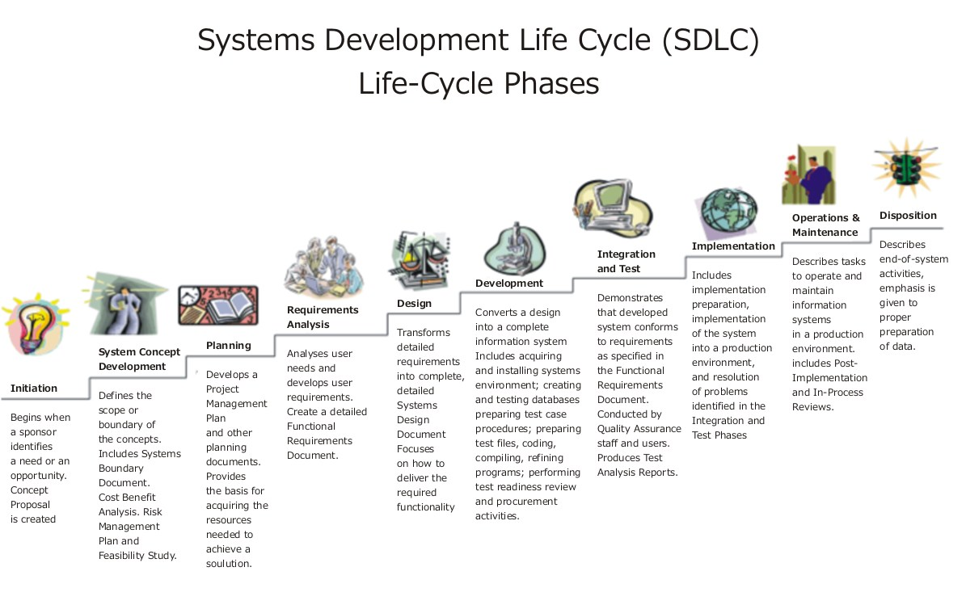**7.1 Initiation**

This phase commmences upon the sponsor acting upon either a requirement within the business or a requirement of the business to change.

### **7.2 Enterprise Analysis**

The objectives of this phase are to define the needs of the business, assess the gaps in capability, determine the approach to the solution and define both the scope of the solution and the business case.

1. Define the needs of the business: The aim of this activity is to identify and define why organizational systems or capabilities need to change.
2. Assess the gaps in capability: The aim of this activity is to identify what new capabilities are required by the enterprise to meet the needs of the business.
3. Determine the approach to the solution: The aim of this activity is to determine which approach to the solution is the most viable one to meet the need of the business. This approach needs to be sufficiently detailed to be able to be used as input for definition of the solution scope and the preparation of the business case.
4. Define the scope of the solution: The aim of this activity is to define the new capabilities that the project or iteration will deliver.
5. Define the business case: The aim of the activity is to determine whether or not an organization is able to justify the investment required to commission a project or iteration to deliver a proposed solution.

### **7.3 Business Analysis Planning and Monitoring**

The objectives of this phase are to plan the approach to business analysis, conduct an analysis of the stakeholders, plan the business analysis activities, communications and requirements management process and manage the performance of business analyst activities.

1. Plan the approach to business analysis: The aim of this activity is to select the best approach to performing business analysis, identifying which stakeholders need to be involved in the decision and who will be consulted and informed of the approach.
2. Conduct an analysis of the stakeholders: The aim of this activity is to identify those stakeholders who may be affected by a proposed initiative, those who share a common need at the business need, those who are able to influence a stakeholder and those members of internal or external authority bodies who approve project deliverables.
3. Plan the business analysis activities: The aim of this activity is to identify the deliverables that must be produced, define the activities that are needed to produce these deliverables, sequence these activities, estimate activity resources, estimate activity durations and identify the management tools that are required to measure the progress of those activities and deliverables.
4. Plan the business analysis communications: The aim of this activity is to describe the communication structure and schedule and organize and record the activities for setting the expectations of business analyst activities, meetings and others.
5. Plan the requirements management process: The aim of this activity is to approve the implementation requirements and define how changes to the scope of either the requirements or solution will be managed.

### **7.4 Elicitation**

The objectives of this phase are to prepare for elicitation activity, conduct the elicitation activity and document and confirm the elicitation results.

1. Prepare for elicitation activity: The aim of this activity is to ensure that all the resources required for conducting the elicitation activities are organized and scheduled.
2. Conduct the elicitation activity: The aim of this activity is to meet with stakeholder(s) to elicit information regarding their needs.
3. Document the elicitation results: The aim of this activity is to document the results of the elicitation meetings with stakeholder(s).
4. Confirm the elicitation results: The aim of this activity is to validate that the stated stakeholder requirements are aligned to the stated needs of the business.

The objectives of this phase are to prioritize, organize, specify and model the requirements, define the assumptions and constraints and verify the quality and validity of the requirements.

1. Prioritize the requirements: The aim of this activity is to grade each stakeholder requirement so that analysis and implementation effort may be guided to satisfying each requirement in a descending list of importance to the business.
2. Organize the requirements: The aim of this activity is to organize the stakeholder requirements in such a way that the listing is complete and may be understood by all stakeholders.
3. Specify and model the requirements: The aim of this activity is to analyze each stakeholder requirement within the context of how the organization currently operates using a combination of statements, matrices, diagrams and models.
4. Define the assumptions and constraints: The aim of this activity is to identify any assumptions made by stakeholders in their stating of their requirements and to identify any constraints which had a bearing on their identifying of their requirements.
5. Verify the quality of requirements: The aim this activity is to ensure that the stakeholder requirement specification and models meet the mandated standard of quality and allows them to be used effectively as a guide in future activity.
6. Validate the requirements: The aim of this activity is to ensure that each requirement in the listing of stakeholder requirements represents a stakeholder requirement and that there is a logical relationship between each requirement in the listing and the stated goals and objectives of the business.

### **7.5 Requirements Management and Communication**

The objectives of this phase are to manage the solution scope and requirements, manage the traceability of requirements, maintain the requirements for re-use and prepare and commmunicate the requirements package.

1. Manage the traceability of requirements: The aim of this activity is to ensure an ongoing linkage between the needs of the business, the requirements of the stakeholders and the solution requirements.
2. Manage the solution scope and requirements: The aim of this activity is to ensure that stakeholders are kept abreast of any changes to either the needs of the business or the scope of the solution to maintain their confidence that their requirements will be fulfilled.
3. Maintain the requirements for re-use: The aim of this activity is to manage the knowledge of the requirements following their implementation.
4. Prepare the requirements package: The aim of this activity is to ensure that the solution requirements are structured and documented is such a way that the stakeholders are able to easily relate solution requirements to their own requirements.
5. Communicate the requirements: The aim of this activity is to ensure that all stakeholders have a common understanding of the solution requirements.

### **7.6 System design**

This phase describes desired features and operations in detail, including screen layouts, [business rules](https://en.wikipedia.org/wiki/Business_rule), [process diagrams](https://en.wikipedia.org/w/index.php?title=Process_diagram&action=edit&redlink=1), [pseudocode](https://en.wikipedia.org/wiki/Pseudocode) and other documentation.

In [systems design](https://en.wikipedia.org/wiki/Systems_design), the design functions and operations are described in detail, including screen layouts, business rules, process diagrams and other documentation. The output of this stage will describe the new system as a collection of modules or subsystems.

The design stage takes as its initial input the requirements identified in the approved requirements document. For each requirement, a set of one or more design elements will be produced as a result of interviews, workshops, and/or prototype efforts.

Design elements describe the desired system features in detail, and generally include functional hierarchy diagrams, screen layout diagrams, tables of business rules, business process diagrams, pseudo-code, and a complete entity-relationship diagram with a full data dictionary. These design elements are intended to describe the system in sufficient detail, such that skilled developers and engineers may develop and deliver the system with minimal additional input design.

### **7.7 Development**

### The real code is written here.

For Eg.

<?php

$con=mysqli_connect("localhost","root","");

mysqli_select_db($con,"movies");

$movie_title=$_GET["movie_title"];

$director_name=$_GET["director_name"];

$actor_name1=$_GET["actor_name1"];

$genre=$_GET["genre"];

if($_REQUEST['button']=='Update')

{

mysqli_query($con,"UPDATE movie_details SET movie_title ='$movie_title', director_name='$director_name', actor_name1 ='$actor_name1', genre='$genre' WHERE movie_title = '$movie_title'");

}

$query=mysqli_query($con,"select * from movie_details where movie_title='$movie_title'");

echo "<table class='styled' border=\"1\">";

echo "<tr><td class='head'>"."movie_title"."</td><td class='head'>"."director_name"."</td><td class='head'>"."actor_name1"."</td><td class='head'>"."genre"."</td><td>"."</tr></td>";

while($row=mysqli_fetch_array($query))

{

echo "<tr><td class='ele'>".$row['movie_title']."</td><td class='ele'>".$row['director_name']."</td><td class='ele'>".$row['actor_name1']."</td><td class='ele'>".$row['genre']."</td><td>"."</tr></td>";

}

echo "</table>";

mysqli_close($con);

?>

### **7.8 Environments**

Environments are controlled areas where systems developers can build, distribute, install, configure, test, and execute systems that move through the SDLC. Each environment is aligned with different areas of the SDLC and is intended to have specific purposes. Examples of such environments include the:

* *Development environment*, where developers can work independently of each other before trying to merge their work with the work of others,
* *Common build environment*, where merged work can be built, together, as a combined system,
* *Systems integration testing environment*, where basic testing of a system's integration points to other upstream or downstream systems can be tested,
* *User acceptance testing environment*, where business stakeholders can test against their original business requirements,
* *Production environment*, where systems finally get deployed to, for final use by their intended end users.

### **7.9 Integration and testing**

This brings all the pieces together into a special testing environment, then checks for errors, bugs and interoperability.

The code is tested at various levels in [software testing](https://en.wikipedia.org/wiki/Software_testing). Unit, system and user acceptance testings are often performed. This is a grey area as many different opinions exist as to what the stages of testing are and how much, if any iteration occurs. Iteration is not generally part of the waterfall model, but the means to rectify defects and validate fixes prior to deployment is incorporated into this phase.

### **7.10 Training and transition**

Once a system has been stabilized through adequate testing, the SDLC ensures that proper training on the system is performed or documented before transitioning the system to its support staff and end users.

Training usually covers operational training for those people who will be responsible for supporting the system as well as training for those end users who will be using the system after its delivery to a production operating environment.

After training has been successfully completed, systems engineers and developers transition the system to its final production environment, where it is intended to be used by its end users and supported by its support and operations staff.

### **7.11 Acceptance, installation and deployment**

This is the final stage of initial development, where the software is put into production and runs actual business.

### **7.12 Operations and maintenance**

During the maintenance stage of the SDLC, the system is assessed to ensure it does not become obsolete. This is also where changes are made to initial software. It involves continuous evaluation of the system in terms of its performance.

The [deployment](https://en.wikipedia.org/wiki/Software_deployment) of the system includes changes and enhancements before the decommissioning or sunset of the system. [Maintaining](https://en.wikipedia.org/wiki/Software_maintenance) the system is an important aspect of SDLC. As key personnel change positions in the organization, new changes will be implemented. There are two approaches to system development; there is the traditional approach (structured) and [object oriented](https://en.wikipedia.org/wiki/Object_oriented). Information Engineering includes the traditional system approach, which is also called the structured analysis and design technique. The object oriented approach views the information system as a collection of objects that are integrated with each other to make a full and complete information system.

### **7.13 Evaluation**

The final phase of the SDLC is to measure the effectiveness of the system and evaluate potential enhancements.

Some companies do not view this as an official stage of the SDLC, while others consider it to be an extension of the maintenance stage, and may be referred to in some circles as post-implementation review. This is where the system that was developed, as well as the entire process, is evaluated. Some of the questions that need to be answered include: does the newly implemented system meet the initial business requirements and objectives? Is the system reliable and fault-tolerant? Does the system function according to the approved functional requirements? In addition to evaluating the software that was released, it is important to assess the effectiveness of the development process. If there are any aspects of the entire process, or certain stages, that management is not satisfied with, this is the time to improve. Evaluation and assessment is a difficult issue. However, the company must reflect on the process and address weaknesses.

### **7.14 Disposal**

In this phase, plans are developed for discarding system information, hardware and software in making the transition to a new system. The purpose here is to properly move, archive, discard or destroy information, hardware and software that is being replaced, in a manner that prevents any possibility of unauthorized disclosure of sensitive data. The disposal activities ensure proper migration to a new system. Particular emphasis is given to proper preservation and archival of data processed by the previous system. All of this should be done in accordance with the organization's security requirements.

**8. FRONT END MODULES**:

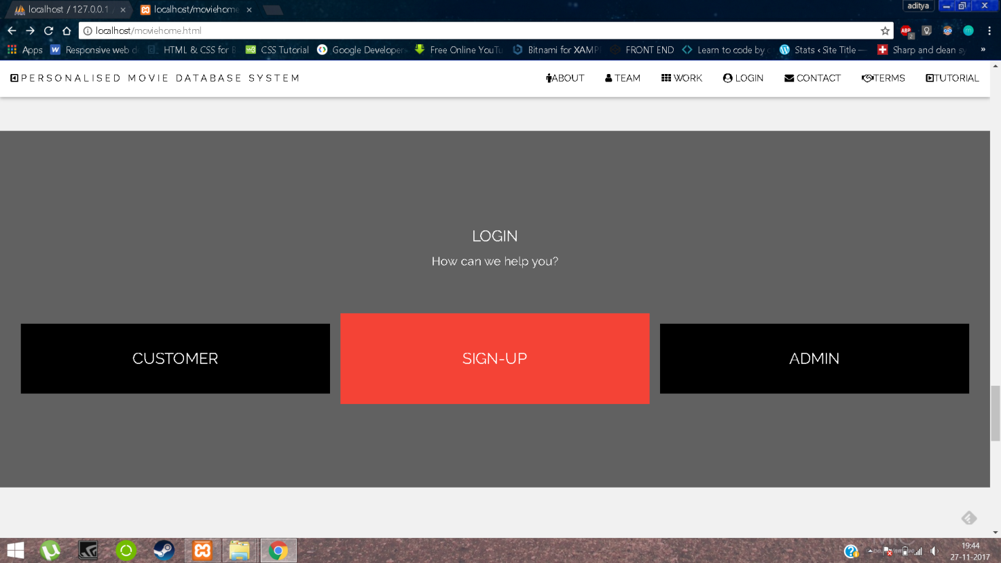

**8.1 ADMIN:**

The Administrator module holds the login page which is basically operated by the administrators in order to modify the data and enhance user interaction by adding the respective data for the website or by removing the same. It is basically done by using Data Manipulation Language at the back end.

The login page is secured with 128-Bit Encryption to avoid any breach to the website. It is accessed by username and the password of the administrator only.

**8.2 CUSTOMER:**

The Customer module holds the login page which is operated by the customers only in order to search for the data they want. Customer data is also secured with 128-Bit Encryption so is to avoid leakage of the information. The program for searching the data by refining it up to the desirable extent runs at the back end.

The customer can perform searching in any way they like as if they want to search the movie by its name, they can do or by the name of the artist performing in the movie can be searched easily by a single click. The details about the movie like star cast, rating, length of the movie, director, budget, gross earning (approx. value), company name, release date, permissions etc.

**8.3 SIGN UP:**

The Sign up module gives the user privilege to register himself/herself on the website and enrich his/her knowledge in movies by searching and viewing the contents related to a particular desired movie.

**8.4 FEEDBACK FORM:**

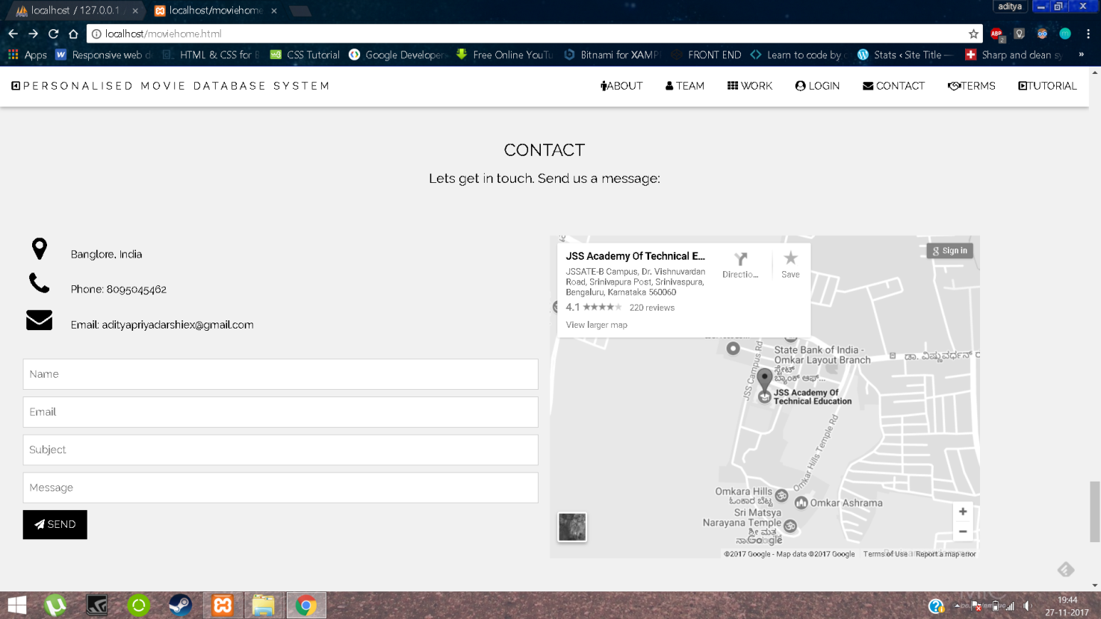

This module is basically used for the interaction between the user and the administrators and also allows user to provide healthy feedbacks for the development of the application or to report any bug.

**8.5 ABOUT THE SITE:**



**Responsive**

Web pages can be viewed using many different devices: desktops, tablets, and phones. Your web page should look good, and be easy to use, regardless of the device.

**Passion**

As our name suggests, we have a passion for all things creative. We can help you find that point of difference and tell your story in a creative way.

**Design**

Design is concerned with what the user actually sees on their computer screen or mobile device, and less so about the mechanisms beneath the surface that make it all work.

**Support**

At WEB-TECH Customer Service is an integral part of our job. Our most vital assets are you – our customers. Without you, we would not and could not exist.

**TERMS AND CONDITIONS**

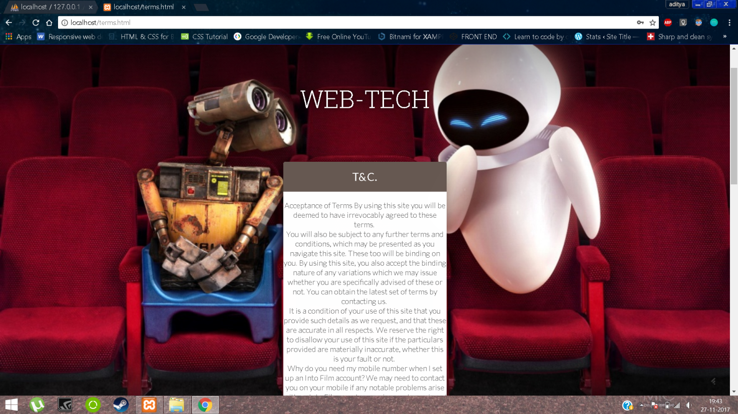

Acceptance of Terms By using this site you will be deemed to have irrevocably agreed to these terms. The terms and conditions have been mentioned on our Site.

**TUTORIAL**

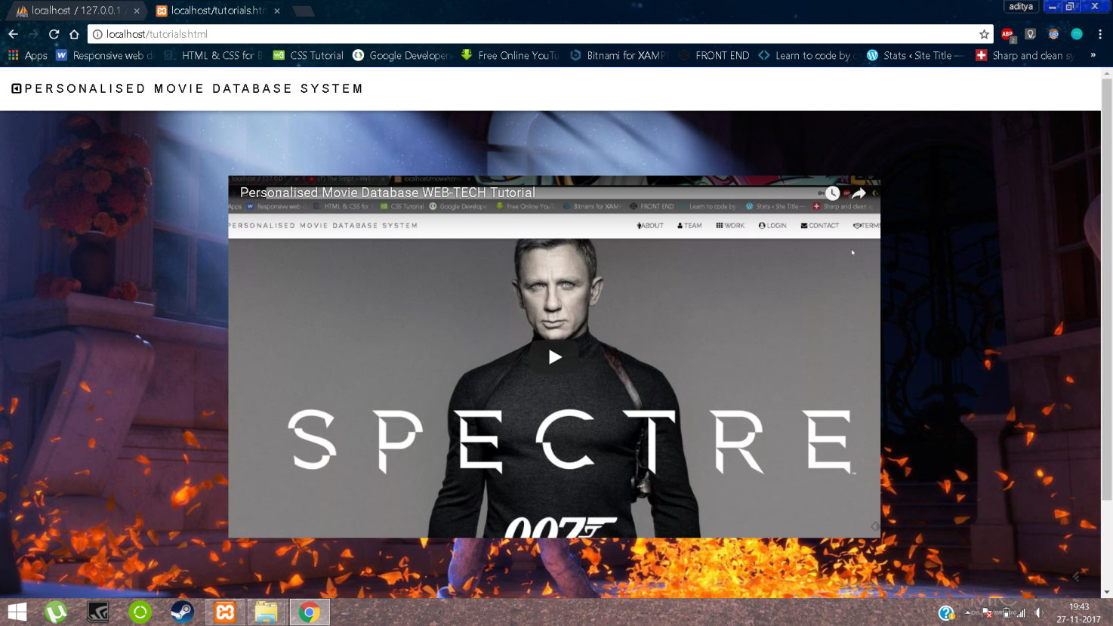

WEB-TECH also provides for its new user tutorial video present in navigation-bar for proper usage of site.

**9. KEY-FEATURES**

**1. INSERT:**

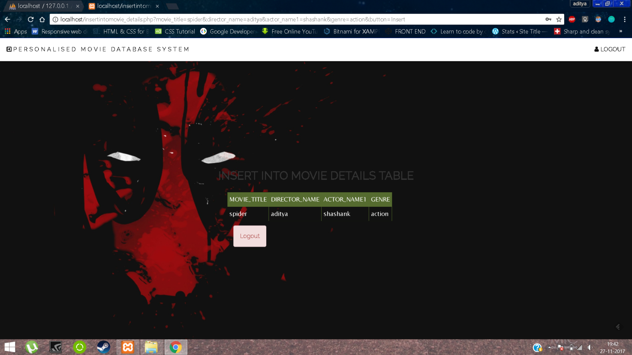

Insert is a widely-used command in the Structured Query Language (SQL) data manipulation language (DML) used by SQL Server and Oracle relational databases. The insert command is used for inserting one or more rows into a database table with specified table column values. The first DML command executed immediately after a table creation is the insert statement.

**2. DELETE:**

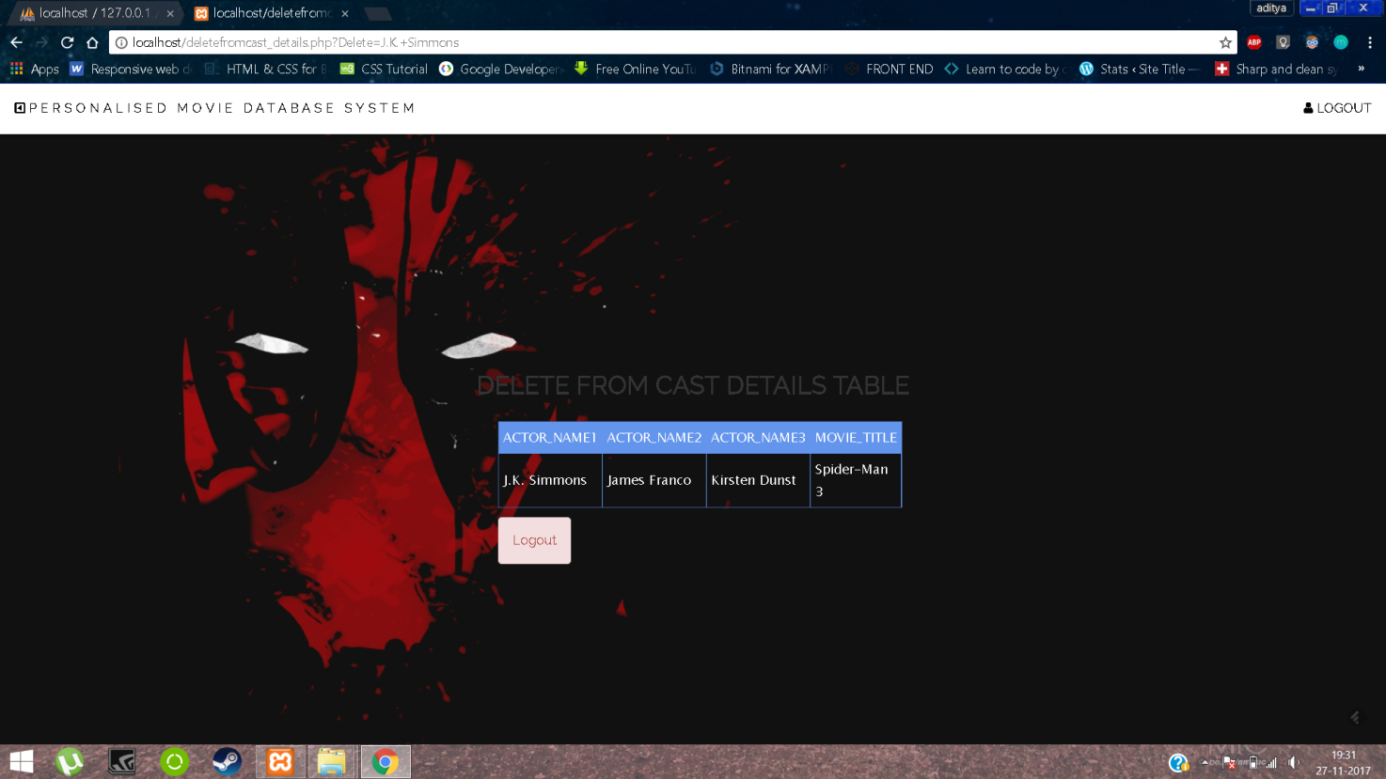

In the database structured query language ([SQL](https://en.wikipedia.org/wiki/SQL)), the DELETE statement removes one or more records from a [table](https://en.wikipedia.org/wiki/Table_(database)). A subset may be defined for deletion using a condition, otherwise all records are removed.[[1]](https://en.wikipedia.org/wiki/Delete_(SQL)#cite_note-1) Some DBMSs, like MySQL, allow deletion of rows from multiple tables with one DELETE statement (this is sometimes called multi-table DELETE).

**3. UPDATE:**

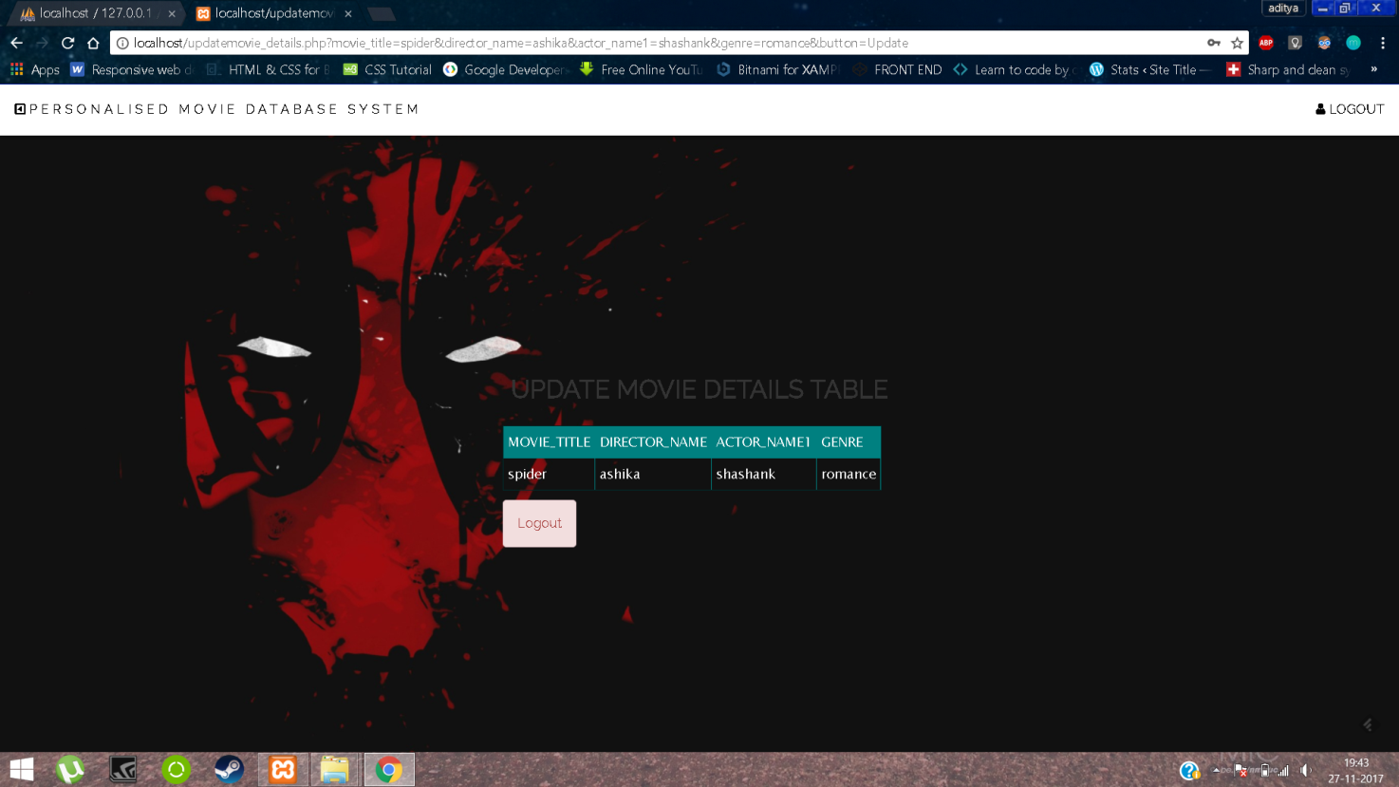

An [SQL](https://en.wikipedia.org/wiki/SQL) UPDATE statement changes the data of one or more records in a [table](https://en.wikipedia.org/wiki/Table_(database)). Either all the rows can be updated, or a subset may be chosen using a [condition](https://en.wikipedia.org/wiki/Condition_(SQL)). For the UPDATE to be successful, the user must have data manipulation privileges (UPDATE privilege) on the table or column and the updated value must not conflict with all the applicable constraints (such as [primary keys](https://en.wikipedia.org/wiki/Primary_key), unique indexes, [CHECK constraints](https://en.wikipedia.org/wiki/Check_Constraint), and [NOT NULL](https://en.wikipedia.org/wiki/Null_(SQL)) constraints).

**4. SEARCH:**

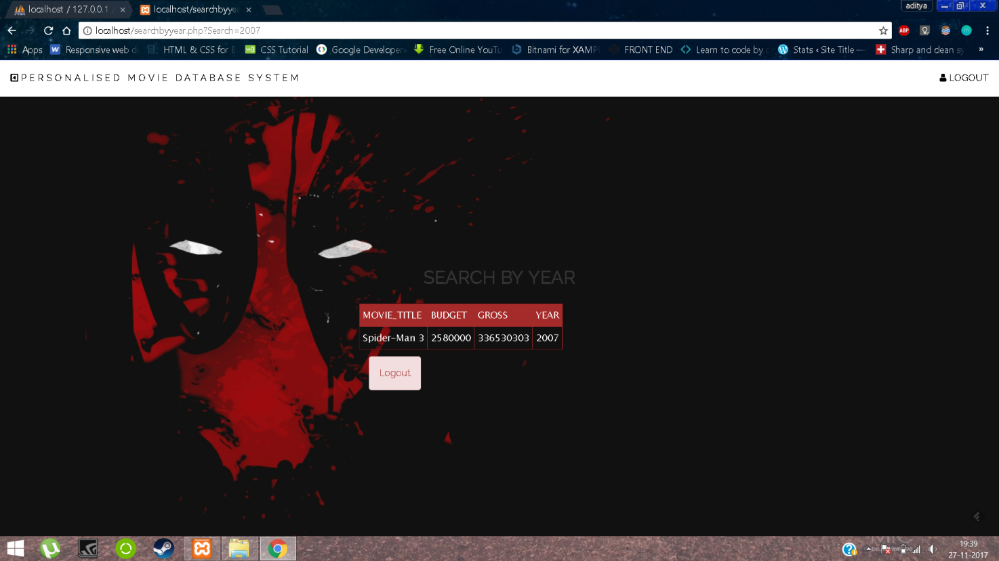

Sometimes, you just want to do a search in a SQL Server database as if you were using a search engine like Google. Besides the obvious Full-Text search, there are plenty of techniques for finding that pesky data that resists the normal SELECT blandishments.

For most of the time you will get adequate powerful searches from a well-normalized database that has all possible constraints and indexes. Just occasionally, usually when you’re searching through text, or you’ve inherited the work of someone whose major talents lie in other areas of life, you need other magic. This article is about some of the SQL magic that might be required.

**5. PROCEDURES:**

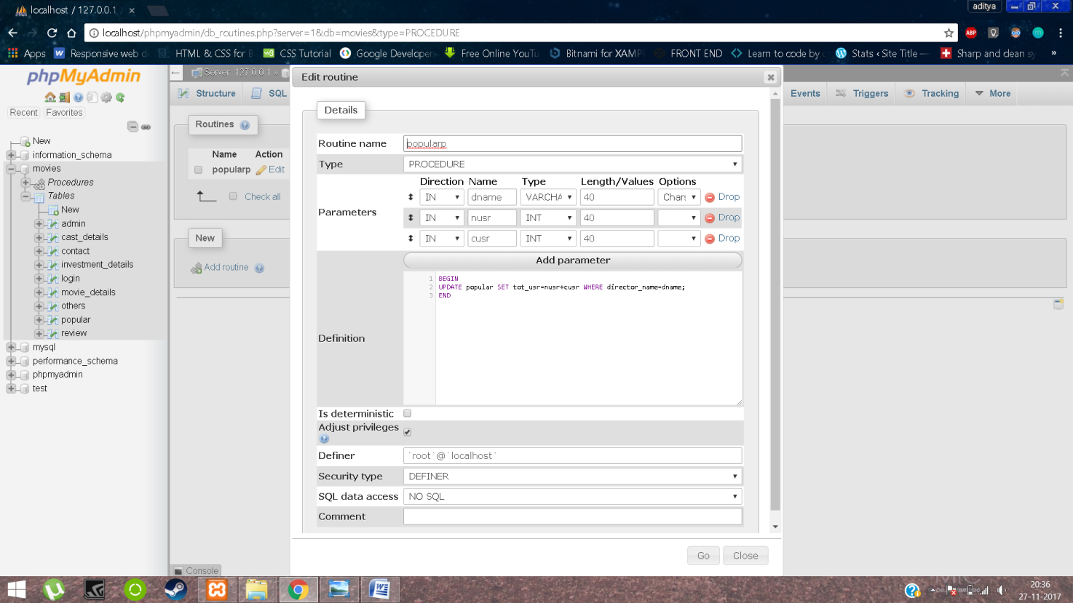

A procedure (often called a stored procedure) is a subroutine like a subprogram in a regular computing language, stored in database. There are many useful applications of SQL procedures within a database or database application architecture. SQL procedures can be used to create simple scripts for quickly querying transforming, updating data, generating basic reports, improve application performance, modularizing applications, and improve overall database design, and database security.

**6. TRIGGERS:**

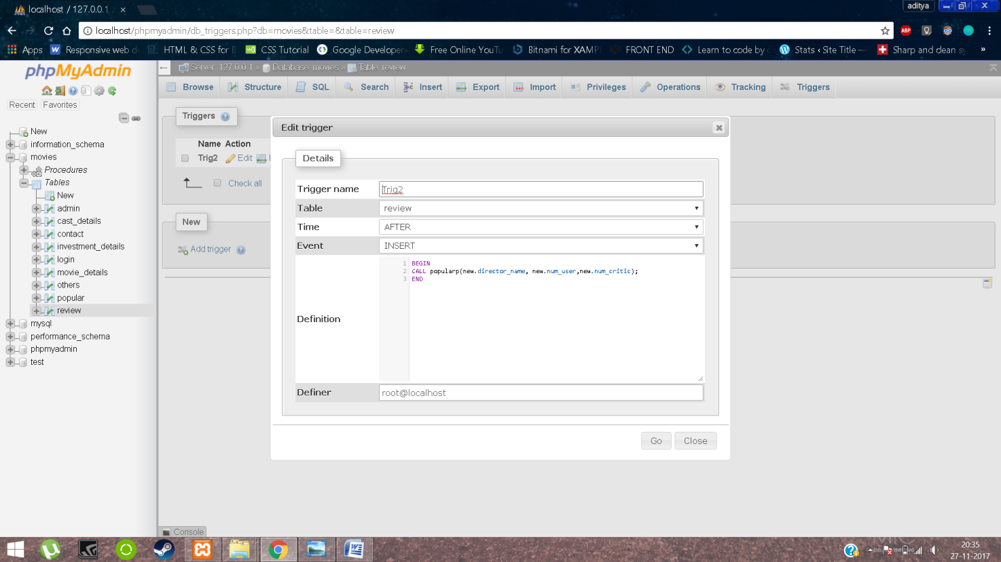

The MySQL trigger is a database object that is associated with a table. It will be activated when a defined action is executed for the table. The trigger can be executed when you run one of the following MySQL statements on the table: **INSERT, UPDATE and DELETE** and it can be invoked before or after the event.

**7. JOINS:**

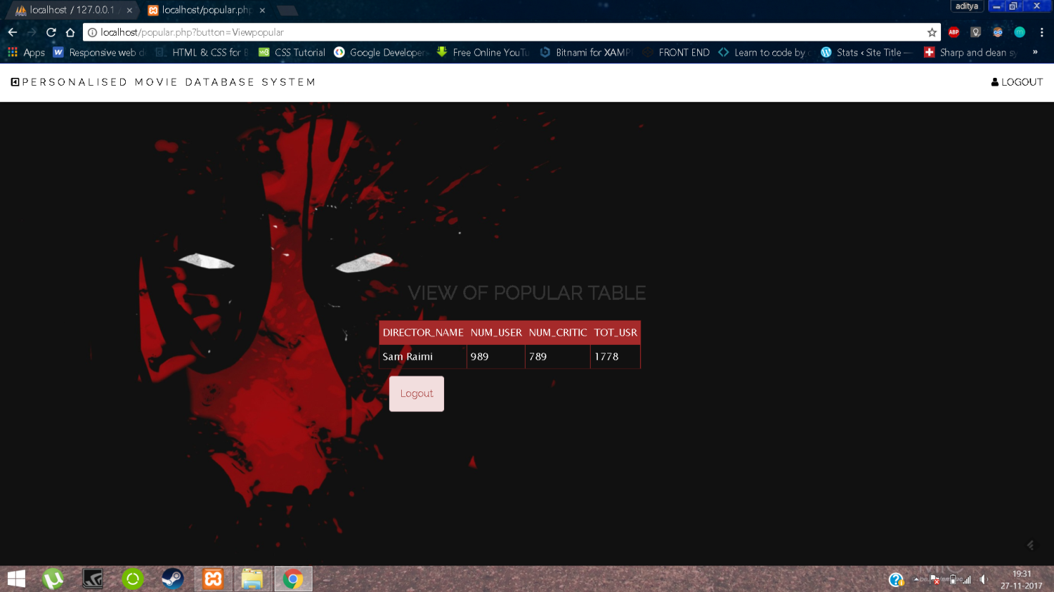

An [SQL](https://en.wikipedia.org/wiki/SQL) join clause combines [columns](https://en.wikipedia.org/wiki/Column_(database)) from one or more [tables](https://en.wikipedia.org/wiki/Table_(database)) in a relational [database](https://en.wikipedia.org/wiki/Database). It creates a set that can be saved as a table or used as it is. A JOIN is a means for combining [columns](https://en.wikipedia.org/wiki/Column_(database)) from one (self-join) or more tables by using values common to each. [ANSI](https://en.wikipedia.org/wiki/American_National_Standards_Institute)-standard SQL specifies five types of JOIN: INNER, LEFT OUTER, RIGHT OUTER, FULL OUTER and CROSS. As a special case, a table (base table, [view](https://en.wikipedia.org/wiki/View_(database)), or joined table) can JOIN to itself in a self-join.

A programmer declares a JOIN statement to identify rows for joining. If the evaluated predicate is true, the combined row is then produced in the expected format, a row set or a temporary table.

**CONCLUSION**

PMDS is a application developed as a handy one-stop destination for a user who is interested to see the ratings, gross, cast, movie details etc. It is successful in meeting the application requirements and there is a lot of scope for future development.

**BIBLIOGRAPHY**

1. *http://www.imdb.com/*
2. *https://www.themoviedb.org/*
3. *https://movielens.org/*
4. *https://developers.themoviedb.org/3/getting-started*
5. *https://www.themoviedb.org/documentation/api*
6. *https://www.lifewire.com/internet-movie-database-3482288*
7. *Effective MYSQL BACKUP and Recovery by Ronald Bradford*